**Experiment 2.4**

Student Name: YANA SRIVASTAVA UID: 20BCS2279

Branch: CSE Section/Group:20BCS_WM_906/B Semester: 5th Date of Performance: 04-11-22

Subject Name: Machine Learning Lab Subject Code: 21CSP-317

1. **Aim/Overview of the practical:**

Decision Trees on digits dataset**.**

1. **Source Code:**

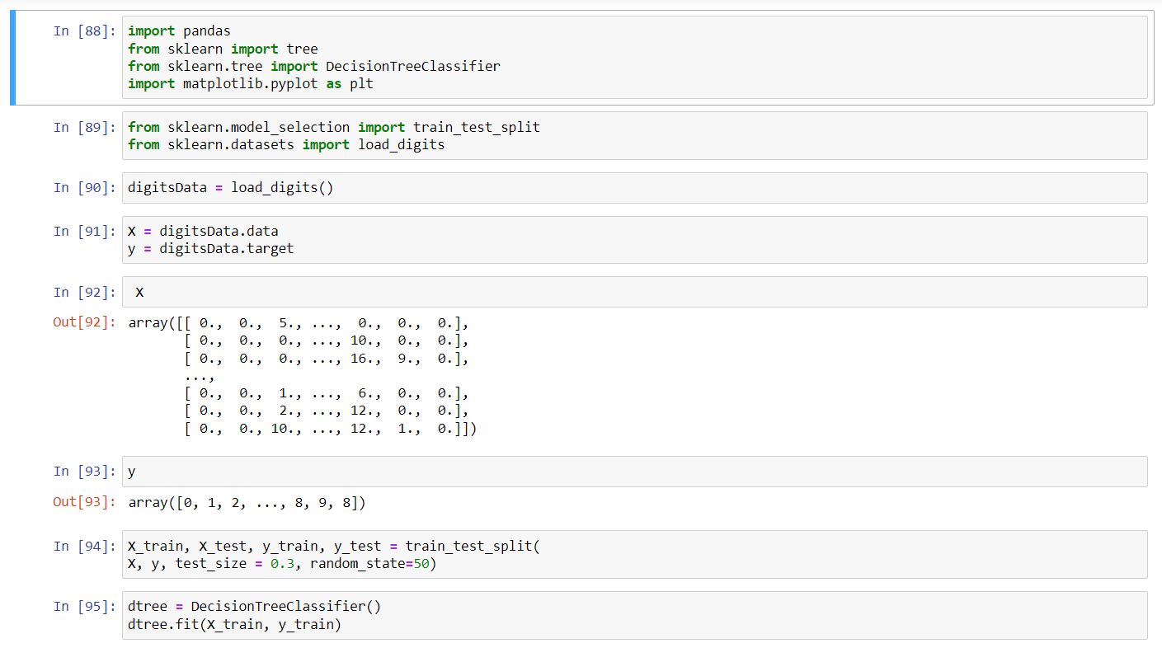

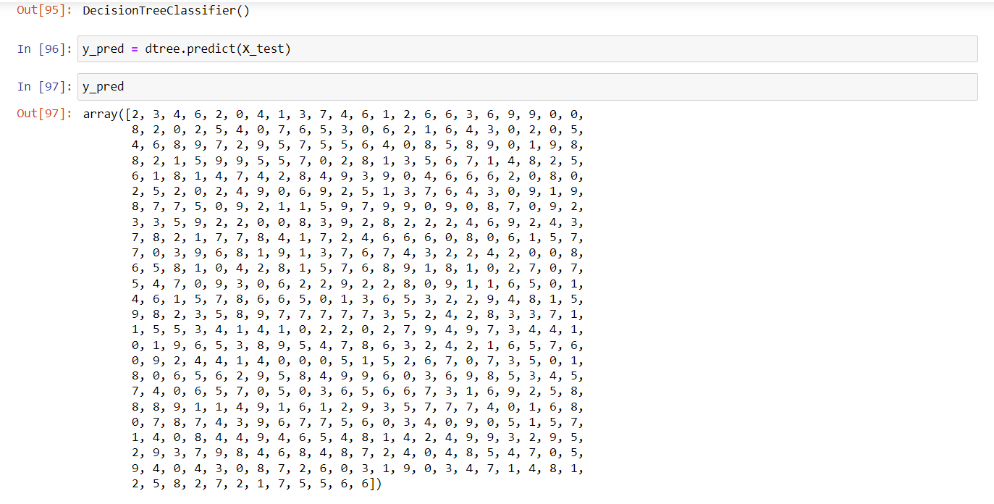

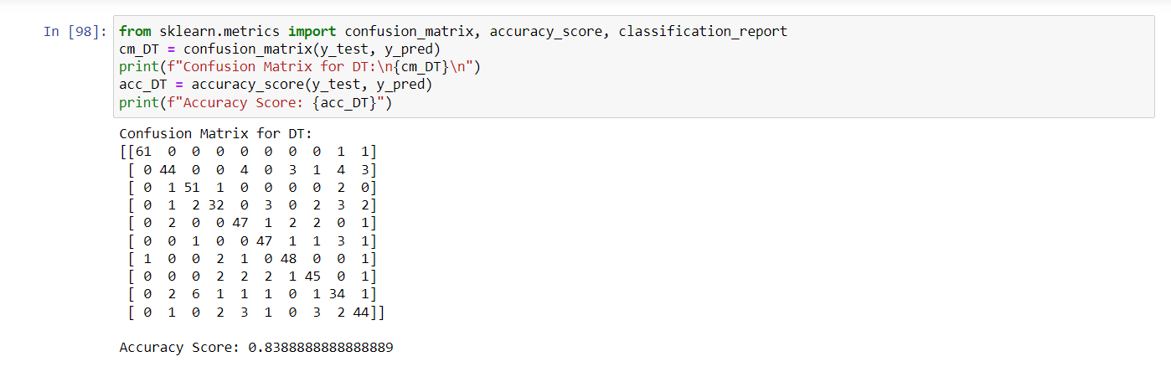

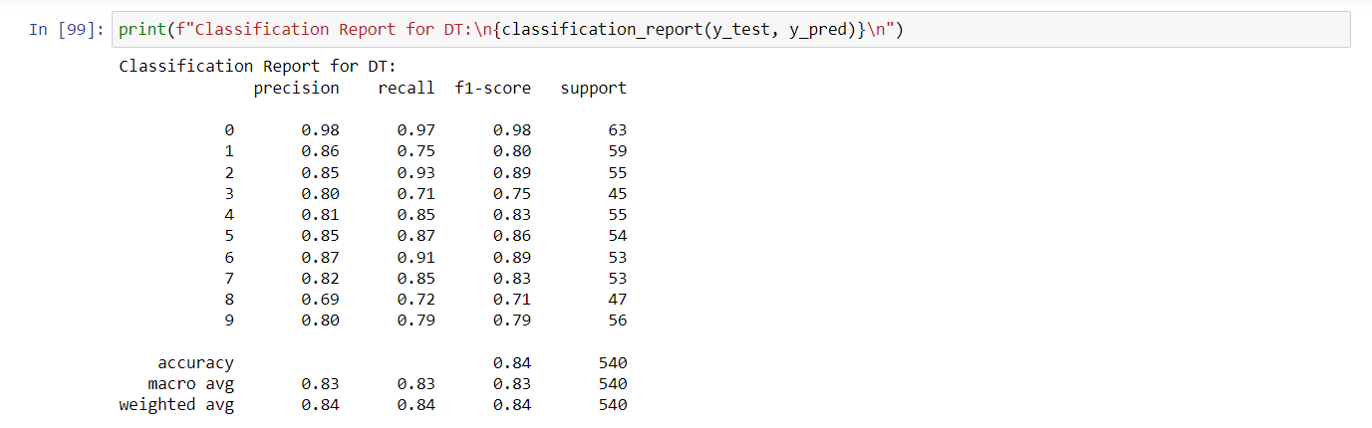

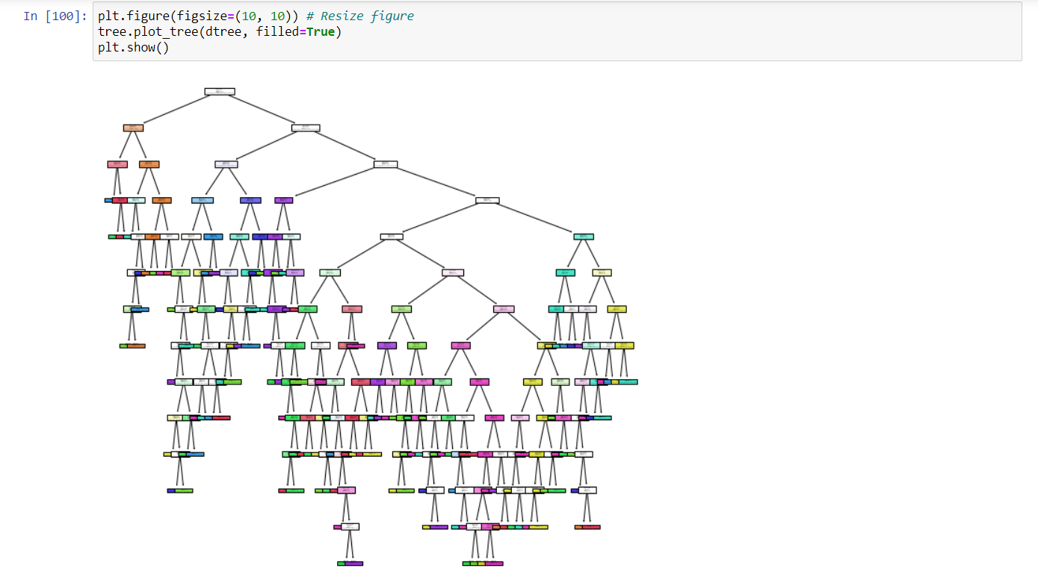

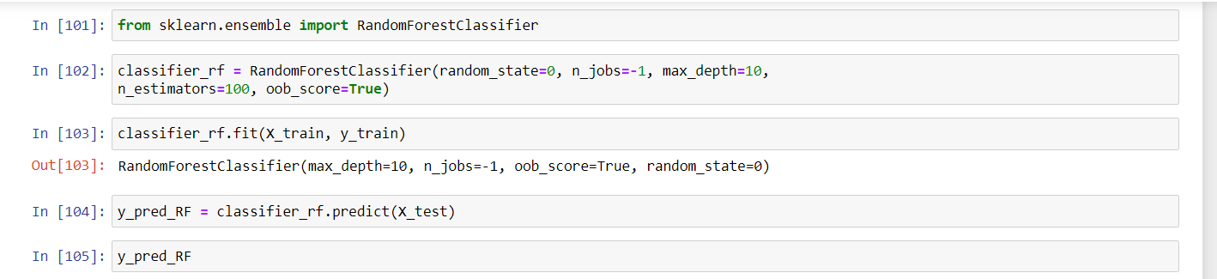

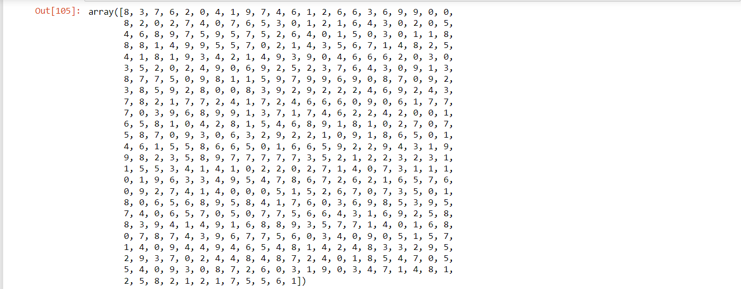

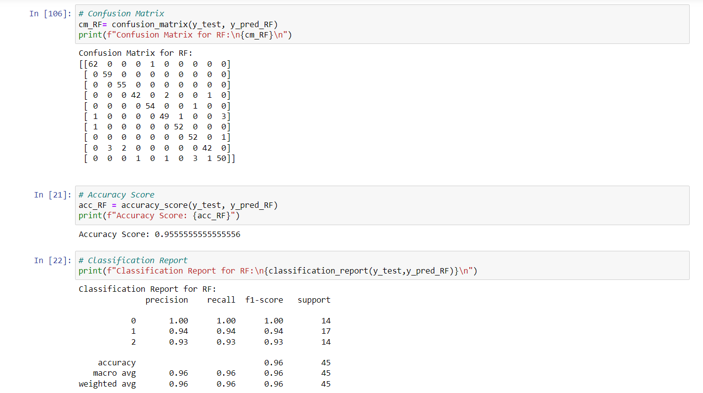

Learning outcomes (What I have learnt):

* 1. Learn about the Decision Trees.
  2. Learn to perform the decision tree on digits dataset.
  3. Learnt about the exploratory data analysis.
  4. Learn to optimize the Model.